Università LUMSA - Roma
Marketing & Digital Communication Curriculum
Fundraising and sponsorships Course
A.A. 2021/2022 Semester 2
Course Syllabus
Teacher:
Chiara Aluffi Pentini - chiaraluffi@yahoo.com
Web references

Teacher page: (for location and timings of 1to1 conversations): https://www.lumsa.it/chiara-aluffi-pentini?nf=2254&tpage=docenti

Webreferences
Teacher’s page: Course objectives:
- Learn theories and concepts of fundraising
- Be able to design, implement and evaluate a fundraising strategy
- Get a practical understanding of the most used channels and communication tecniques used for raising funds
Course methodology:
- Lectures
- Class discussions and activities
- Reading assignments
- Written Assignments
- Student presentations
Instructor’s Expectations:
- Participation in class with questions, comments and examples is fundamental.
- Students are expected to do the assigned readings and during each class we will have comments or questions on the readings.
- Assignments should be well edited as well as have strong content. Please send them via email, or upload them on the elearning platform in a format where I can add my own comments and good to be presented to the rest of the class.
- Timeliness of papers is an important factor.
- Electronic devices can only be used in class for course purposes

Assignments
Based on number of people attending the course and the evolution of the pandemic, the assignments will be given as group assignments or as individual assignments

Grading/Assigned readings

Readings in preparation for the classes will be shared at a later stage

Textbooks (mandatory reading)

One among the 2 books following

Valerio Melandri, Creating stronger donor relationships to sustain your nonprofit for the really long haul, Civil Sector Press, Canada, 2017. 358 pages (on order in the LUMSA Library)
  - Sargeant - Fundraising Principles and Practice - 2nd edition,2017 – Wiley (available in the LUMSA library)

2. One among the 2 books following

Scott Harrison - Thirst – Currency (available in the LUMSA library)

Ambrogetti: Emotionraising (available in the LUMSA library in Italian, on order in English)
Suggested Resources (Not Mandatory)
In English
- Subscription to Inside Philantropy
- https://sofii.org/
- https://www.fondazionelangitalia.it/en/
- http://www.aherncomm.com/
- https://www.managementcentre.co.uk/fundraising-case-studies/
In Italian:
- www.vita.it
- https://www.facebook.com/groups/fundraisersitalia/

FOR THE SPECIFIC CHAPTERS TO BE STUDIED SEE THE BLUE TABLE BELOW
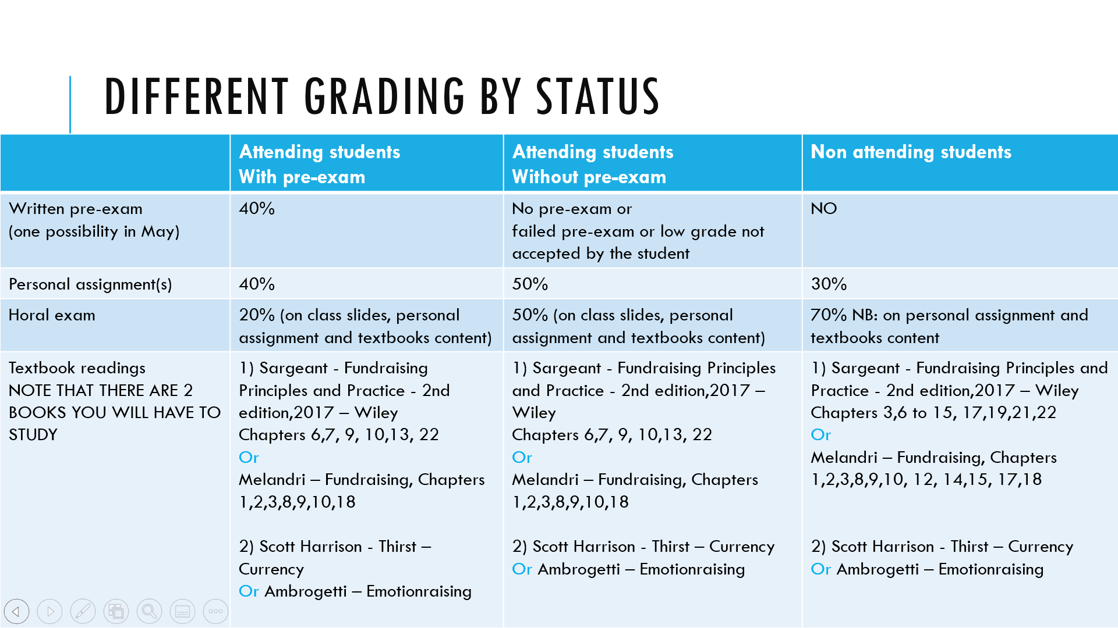
ASSIGNMENTS FOR STUDENTS ATTENDING CLASSES – WILL BE UPDATED AS THE COURS PROGRESSES
Class | Topic | Attending students: assignment for next class
1 | Course Intro  History of Fundraising  Fundraising stats | - Read https://www.nytimes.com/2019/12/03/opinion/giving-tuesday-motivation-generosity.html  - Choose 2 charities to monitor, subscribe to newsletter and – possibly – make a small internet donation  - Think about a situation in which you have been requested to donate and about the reasons you donated/you did not donate  - Watch https://www.ted.com/talks/michael_norton_how_to_buy_happiness?language=en  and be ready to discuss this in class
2 | Emotions | - For the 2 charities you have chosen  - Review their website or videos  - Identify pieces of communication where they have leveraged emotions.  - Place the emotions on the emotion meter  - Review the science of emotions theory at at https://sofii.org/article/cde-project-6-the-use-and-misuse-of-emotion-section-3-the-science-of-emotions  - Describe a piece of communication you would build for your charity to create the same empathy we felt for Notre Dame or the same empathy communicated by EBRI videos or Save the Children videos
3 | Role of the brand  Case for support | - Write a 6 words story about:  - - either the charity you have chosen  - - or an invented charity  - Write a case for support following the indications of this class  - for one of of the 2 charities you have chosen to monitor  OR  - for a charity you have created (think about one issue that is important for you and invent an organization focused on solving it)
4 | Lovemark (Sick Kids)  Fundraising audit  Targeting | - Prepare SWOT ANALYSIS for your charity*  - Identify 1 user persona/target audience for your charity* and build the empathy map
5 | Behavioural economics, Regular donation product | Design your regular/mixed giving proposition for your charity and for your empathy map target  - Naming  - Features  - Price levels  - Communication  - If you want, not compulsory, try to leverage the Hooked model  - Review the 50 cognitive biases  - https://www.visualcapitalist.com/50-cognitive-biases-in-the-modern-world/ (prioritize the ones with money)  - https://en.wikipedia.org/wiki/List_of_cognitive_biases  - Identify one you are interested in and try to think how to leverage/neutralize it as a charity
6 | Retention | Exercises to calculate retention
7 | Fundraising channels | Review the different videos  Review different examples of direct mail pieces  https://sofii.org/tags/Direct%20mail  Design a Direct Mail pack for your organization  - Be creative on the envelope  - Write a text with a story, with data, with call to action  - Define the ask  - Surprise your donors!
8 | Rete del Dono Crowdfunding and Personal Fundraising & Fundraising Channels | Read this article  https://insight.kellogg.northwestern.edu/article/paper-vs-digital-requests  Review/Refine/improve the Direct Mail pack for your organization  - Be creative on the envelope  - Write a text with a story, with data, with call to action  - Define the ask  - Surprise your donors!
9 | Sponsorships
10

At the end of the course students attending classes will be asked to review their individual assignments based on the overall learnings from the course and put them together in one single document, to be delivered one week before the final exam. (3 days for the ones sustaining the exam in the May session)
------

- FINAL ASSIGNMENT FOR STUDENTS NOT ATTENDING CLASSES: WRITE A FUNDRAISING PLAN
- Choose an existing charity you are interested in
- Review their website and annual report, indicating:
  - 3 things you like related to what you have learned during the course,
  - 3 things they could do better linking it with the course topics.
- Choose one charity you want to focus on or invent one (preferred)
- Write a Case for support:
  - Review key elements of case for support in textbook and here https://garecht.com/sample-case-for-support/
  - Write a case for support for the charity based on public information on the website and
- Prepare a SWOT Analysis for you chosen charity
- Define a regular giving proposition for your charity, identifying:
  - Frequency of payment
  - Program supported
  - Asks level (and related link to program)
  - Advantages/Communication for regular givers
- Write a direct mail piece asking somebody to make a donation to your charity
- Write an individual plan for a potential major donors to be involved with the charity you have chosen
- Identify a corporate partner that can be interested in donating to your charity, and prepare a proposal for the prospect corporate partner that shows which benefits your organization can give to this corporate partner.
Please note that the materials proposed for existing charities have to be original, any copied content will lead to a refusal to assign a grade and require a submission of a new assignment.

